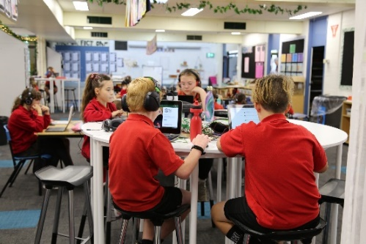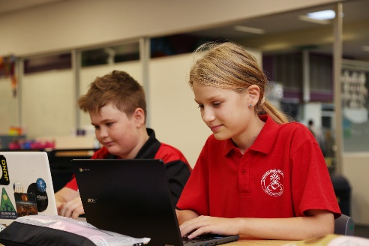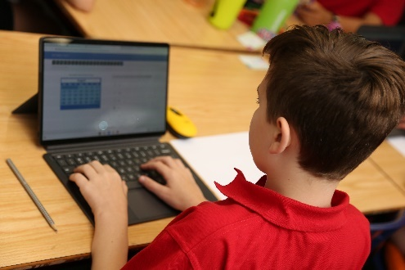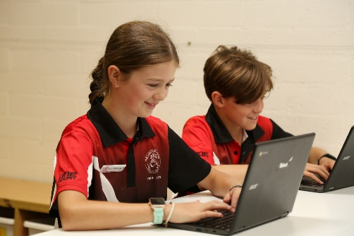

**Bring Your Own Chromebook (BYOC)**Parent Information Pack

**ACT Education Personal Electronic Devices (PED)**

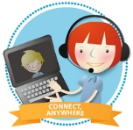**Personal Electronic Devices (PED’s) in schools**

The ACT Education Directorate [*Connect Everywhere*](https://www.education.act.gov.au/public-school-life/learn-anywhere-ict-for-students/connect-anywhere#:~:text=Our%20students%20can%20bring%20their,own%20personal%20device%20of%20choice.) initiative allows for students to bring their own device to school and access the high-speed filtered wireless internet, available in all ACT Public Schools.

Using their ACT Education SchoolsNET username and password, students can be connected on their own personal device, making learning more personalised and student-centred, catering to different learning styles.

**How and why are Personal Electronic Devices Useful?**

**Connecting** — Students bring their own devices to school for educational purposes to access software, the internet and the Directorate’s network via Wi-Fi, they become familiar and confident with one device and develop an attachment and awareness for the maintenance of their own device.

**Learning** — Use of personal devices helps to provide student-centred learning, personalised learning experiences for students and can cater to different learning styles where all students become engaged.

**Teaching** — Teachers will collaborate with their students and use personal devices as tools that develop student information and communication technology literacy skills—seeking, analysing, evaluating, problem solving, decision making, presenting and communicating.

**Personal Electronic Device (PED) Policy**

The ACT Education Directorate has a [policy](https://www.education.act.gov.au/publications_and_policies/School-and-Corporate-Policies/Computers_Devices-and-Internet/internet-and-online-communication-services/use-of-personal-electronic-devices-policy) on the use of personal electronic devices in schools. Relevant policy links:

* [Use of Personal Electronic Devices Policy](https://www.education.act.gov.au/publications_and_policies/School-and-Corporate-Policies/Computers_Devices-and-Internet/internet-and-online-communication-services/use-of-personal-electronic-devices-policy).
* [Communities online: Acceptable use of ICT – Parents and Students Policy](https://www.education.act.gov.au/publications_and_policies/School-and-Corporate-Policies/Computers_Devices-and-Internet/internet-and-online-communication-services/communities-online-acceptable-use-of-ict-parents-and-students-policy)
* [ICT Management in Schools Policy](https://www.education.act.gov.au/publications_and_policies/School-and-Corporate-Policies/Computers_Devices-and-Internet/internet-and-online-communication-services/ict-management-in-schools-policy)

An Acceptable use of ICT Statement (Code of Practice) must be signed by students and parents or carers for all students under the age of 18.

**Device Requirements**

Device requirements and recommendations for Chapman Primary School were established in 2020 in partnership and after consultation with our parent community taking into account the two requirements which are consistent for every ACT Public School on the use of personal devices is that the device:

* should be fully charged for the beginning of each school day,
* is able to connect to our SchoolsNET wireless network.

**Chapman Primary - Bring your own Chromebook (BYOC) choice.**

Chapman Primary School introduced a **Bring Your Own Chromebook** **(BYOC)** policy and program for students in years 4, 5 & 6 in 2020. This has proven to be a productive addition to our classroom learning, offering students a hands-on tool to develop information and communication technology literacy skills in a safe and supportive environment. Students are responsible for bringing their Chromebook to school each day, charged and ready for learning, and will take their devices home each day.

**What is a Chromebook?**

A Chromebook is a simplified version of a typical laptop. Chromebooks are fast, reliable and secure, using Google’s Chrome OS operating system. They are lightweight and affordable making them suitable for primary school students.

Chromebooks are manufactured by many companies and differ slightly in their hardware and presentation, but all run the Google’s Chrome OS operating system. It is critical that students have devices with the same operating system to help our teachers when planning learning programs and trouble shooting.

**Why a Chromebook?**

The reasons why we have chosen Chromebook options include:

* super-fast – starting up in less than 7 seconds,
* high level of processing power,
* long battery life,
* easy to use,
* durability,
* lightweight,
* automatically update,
* compliment the use of Google Apps in schools’ program.

The ACT Council of Parents & Citizens Association offers additional information regarding[*Google Apps in school*](https://www.actparents.org.au/index.php/news1/item/223-q-a-google-apps-in-schools)*.*

**ICT Code of Conduct Agreement**

In line with [ACT Education ICT Management in Schools Policy](https://www.education.act.gov.au/publications_and_policies/School-and-Corporate-Policies/Computers_Devices-and-Internet/internet-and-online-communication-services/ict-management-in-schools-policy) and the *Communities Online: Acceptable use of ICT – Parents and Students Guidelines*, Chapman Primary School has developed a Code of Conduct Agreement which students and their parents / carers are required to sign and return before using a device at school. Agreements will be placed on student files.

**Chapman Primary School ICT Code of Conduct**

The Chapman Primary School *“ICT Code of Conduct – Your Chromebook is a Learning Tool Agreement”* clearly outlines the expectations for students using an electronic device between school and home.

Terms of the agreement are reviewed regularly and may include the following examples:

* I will practice the Chapman Primary School PBL expectations of being responsible, safe and respectful when using my Chromebook.
* I will use my Chromebook only with the permission of a teacher.
* I will follow all instructions from teachers when using my Chromebook.
* I will not share my passwords or usernames with anyone.
* I understand that I am responsible for any content created or access gained when my account is used.
* I understand that the school and the ACT Education Directorate receives information about anything that I view, send or receive.
* I will tell my teacher if I think someone has used my account.
* I will be careful that any email I send or work that I wish to have published uses appropriate language and is thoughtfully written and presented.
* I will respect other students’ work and offer appropriate feedback when invited to.
* I will not read other people’s emails.
* I will not download and save any inappropriate content using my Chromebook.
* I will not share personal information about myself or others, including addresses or telephone numbers, with anyone.
* I will not send photographs of myself or others to anyone.
* I will only use material from other websites if I have permission to do so.
* If I do use material that I have found on the internet in my work, I will say where it comes from.
* If I see or receive any information on the computer that makes me feel uncomfortable or is inappropriate, I will tell a **teacher and my parent / carer** straight away or report it using the **Cyber Safety Button on the Digital Backpack.**

**Safety and Security Commitments:**

* I will not damage or disable the computers, computer systems or computer networks of the school.
* I will be responsible for taking care of my Chromebook.
* I will put my Chromebook in my storage locker when I am not using it.
* I will collect my Chromebook at the end of the day to charge it at home overnight and will bring it back to school each day.

**Consequences for not using the device appropriately.**

The consequences for students who do not use their Chromebook appropriately will include a reminder and review of the agreement, and the student’s family will be contacted to discuss the unsuitable use. There may be restricted use of their Chromebook for a period of time which will be decided in consultation with a teacher and may result in a *Use of My Chromebook Action Plan* being written for continued use.

**Purchasing a Chromebook**

We understand that families are eager to purchase a device for their child in preparation for the new school year. While we are not able to recommend or promote a particular device brand or retailer, Chromebooks are available from many retail outlets who will be able to advise and suggest a suitable device to meet your family circumstances. The list of specifications below may assist you in choosing a Chromebook.

It is important that you keep warranty and insurance in mind when making your purchase as accidental or malicious damage or product faults are the responsibility of the device owner.

**Chapman Primary School requirements and specifications for devices:**

* Must be a Chromebook.
* Must have Wireless connectivity.
* Requires a screen size - at least 10 inches.
* Memory - 2GB of RAM and there is no minimum of internal storage as all student work will be safely saved into the Google Drive.
* Battery life - battery should last 6 hours without charging.
* Protective casing (scratch/impact/liquid-splash resistant).
* Touch screen interactivity is useful bot not necessary.

**Additional accessory requirements**

Students will also require their own:

* Headphones, (you are welcome to source your own headphones, however these are most usually included in year Back to School book pack lists and can be reused from year to year)
* mouse to use with the device,
* Suitable sturdy carry case.

Remember to clearly label your child’s device and their accessories with their full name.

**Equity**

ACT Public Schools provide students with equitable access to ICT for learning. Schools have devices and ICT equipment available for students to use at school.

**Frequently Asked Questions**

**How will this program operate?**

The program is a home to school program which aims to prepare students for the digital world in which they live. The program will put technology at the fingertips of our students allowing them to utilise one device at both home and school. Parents will be able to see what children are working on at school and can build on this where they feel it is appropriate. Teachers, through the Google Suite for schools (GSfS) will be able to manage the individual needs of children and effectively monitor their progress.

**Why doesn’t the school just provide a class set of Chromebooks which the children share?**

Our BYOC program aims to mimic “real use” of ICT which involves having a personal device per child. This facilitates taking the device home, away on holidays, on excursions, and having access to the information they need when they need it. A system based on shared devices allows limited access only and would not allow devices to travel home.

**What if my child doesn’t have a Chromebook? Will they be disadvantaged? Do they have to have one?**

No child will be disadvantaged. All children will continue to access the same level of ICT they currently have. All students are encouraged to have their own Chromebook; however, the school does have some devices available for students to use during in class lessons, allowing the school owned devices to be accessible to all learning areas.

**Does the school have sufficient Wi-Fi access?**

Yes. The school has an upgraded Wi-Fi network across all areas of the school.

**Can my child bring an alternative device to school instead of a Chromebook?**

No. We have chosen the Chromebook due to its long battery life, easy use, quick start up and durable assembly. After considerable research and community consultation, we believe the Chromebook is the ideal device for use at Chapman Primary School.

It is important for our teaching staff that students have comparable devices. Due to the management software the ACT Education Directorate uses, all devices will automatically be updated and synced when in the school environment, thus meaning there is no ongoing requirement to purchase or update educational software. Devices can be used from one year to the next allowing for familiarity and troubleshooting issues to continue.

**Won’t the children just be staring at a screen all day?**

No. A Chromebook is a tool that teachers and children will only use some of the time; it is not suitable for every aspect of learning. Face to face interaction and physical activity will remain a high priority in the classroom and we believe a balance can be achieved. Some forms of learning are still better suited to pen and paper and these decisions will be made keeping student outcomes in the forefront of lesson planning.

**What evidence is there that ICT improves student outcomes?**

Many studies have been carried out in recent times and the evidence shows that when used appropriately ICT can positively impact on student achievements. We believe the use of ICT is another tool to be utilised by teachers to meet the needs of a greater range of learning styles. Many children enjoy using computers and it is this motivation that facilitates learning through focus.

**What are the benefits?**

* Wider access to resources.
* More ability to differentiate.
* Fast retrieval of information.
* Access to real time co-operative learning and schools across the world.
* Ability to link with like-minded students.
* Ability to share learning at home in a timely manner.
* Preparation for real-life situations.
* Student engagement and motivation.

**How much does the Chromebook weigh?**

* 1.1kg approximately.

**What happens if my child accidentally damages their Chromebook at school? At home?**

The care, safety and security of your child’s device is their personal responsibility.

Any defects that occur during the normal use of student’s devices can be covered by warranty or insurance. We suggest you make inquiries about warranty and insurance when making your purchase as accidental damage and product faults are the responsibility of the device owner. We strongly encourage all parents to insure their child’s device. We recommend that parents/carers confirm with their insurance company regarding the cover of personal electronic devices against theft or damage outside of the home.

*\*Damage due to negligence or malicious behaviour is not covered by the manufacturer’s warranty and the parents will be expected to cover the cost of the repair or replacement.*

Our school PED agreement includes information about the safety and security of devices.

**How will my child’s Chromebook be stored safely while at school?**

When not in use, Chromebooks will be stored in students secured lockers within the school.

**Should my child take their Chromebook home each night?**

Yes, because Chromebooks can be used at home by students. Because the school does not have the facilities to charge Chromebooks in the BOYC program, students will charge their Chromebook at home each night and will bring it back to school ready for use the next day at school.

**Do students have unrestricted access to the internet?**

No. Chromebooks connect to software, the internet and the ACT Education network via Wi-Fi. ACT Education ICT management has deployed a content filter to monitor and block internet access for unsuitable site and content. This may at times also hinder access to legitimate sites or content and students should advise their teachers if this happens. The ACT Education *Acceptable use of IT Policy* will continue to be applied.

**What happens to the Chromebook when they go to high school?**

The Chromebook belongs to you, so it is yours to keep.

**Will individual students require a Google account?**

Yes. All students have a Google account as part of the education domain. Students cannot use a Gmail account at school. Students use their SchoolsNET login details for their Google account. Consent is requested when you completed your child’s online an ACT Public School enrolment application.

**What software does it come with?**

The Chromebook operates in the Google Chrome environment. No software is required. Google has their own version of Word, Excel and PowerPoint and all apps are automatically updated every time your child logs on.

**Where can I get some advice about safe and responsible use of social media?**

Chapman Primary School wants all students to be safe, responsible and respectful members of the online community and we ask parents to support our efforts in promoting responsible online behaviour. We provide regular cyber safety lessons for children from kindergarten to year 6 and offer Parent information sessions when available throughout the year. For more information, you may wish to visit one of the following websites:

* <https://www.constablekenny.org.au/parents/online-safety/>
* <https://www.thinkuknow.org.au/>
* <https://www.esafety.gov.au/parents>

**Related Policies and Information**

* [Safe and Supportive Schools](https://www.education.act.gov.au/support-for-our-students/feeling-safe-at-school/safe_supportive_schools)
* [Student Privacy Information](https://www.education.act.gov.au/public-school-life/learn-anywhere-ict-for-students/resources-anywhere-digital-backpack/google-apps-for-education-student-privacy-information)

ACT Government Education Directorate LogoAcceptable Use of ICT – Parents and Students Guidelines: Acceptable Use of Personal Electronic Devices (PEDs) in School Agreement Summary

| Category | Device Requirement | Student responsibility |
| --- | --- | --- |
| **Wireless Connectivity** | The ACT Education Directorate’s Wi-Fi network installed in schools operates on the **802.11n 5GHz standard with WPA2 enterprise security.** Devices that do not meet these specifications may not be able to connect. | Student devices are only permitted to connect to the ACT Education Directorate’s Wi-Fi network while at school. There is no cost for this service. |
| **Operating System** | The current or prior version of any operating system. | Students must ensure they have a legal and licensed version of a supported operating system and of software. |
| **Anti-virus** |  | If applicable, students’ devices must be equipped with anti-virus software. |
| **Software and Apps** | All software and apps should be fully updated. | Students must ensure they bring their device to school fully charged for the entire school day. No charging facilities will be supplied by the school. |
| **Battery life** | A minimum of 5 hours to last the day | Students must ensure they bring their device to school fully charged for the entire school day. No charging facilities will be supplied by the school. |
| **Memory and RAM** | A minimum specification of 16GB storage and 2GB RAM to process and store data effectively. |  |
| **Hardware Features** | Camera and microphone. |  |
| **Ergonomics** | Reasonable sized screen and a sturdy keyboard to enable continuous use throughout the day. | Students should ensure they are comfortable using devices during the school day particularly in relation to screen size, sturdy keyboard etc. |
| **Other Considerations** | Weight: Lightweight for ease of carrying.  Durability: Durable and strong. |  |
| **Insurance/warranty** | Be aware of the terms of insurance policies/warranties for the device. The school will not accept responsibility for loss or breakage. | Students and their parents are responsible for arranging their own insurance and should be aware of the warranty conditions for the device. |
| **Theft and Damage** | * Supply a carry case or skin to protect the device that is durable and strong. * Consider a tough and sturdy case to avoid breakage. | Students are responsible for securing and protecting their devices at school. Any loss or damage to a device is not the responsibility of the school or the Directorate. |
| **Maintenance and Support** |  | Students are solely responsible for the maintenance and upkeep of their devices. |
| **Confiscation** |  | Students’ devices may be confiscated if the school has reasonable grounds to suspect that a device contains data which breaches the *Use of PEDs in School Agreement*. |