15 February 2024
Dear parents and carers
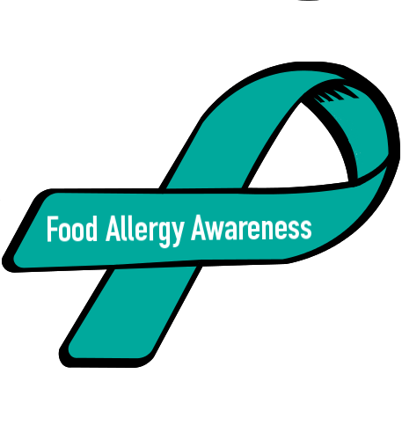
Chapman School Food, Drink and Allergy Awareness Message
Chapman Primary School has a number of students with life threatening allergies or Anaphylaxis reactions to particular foods. The school works closely with families to put in place personal plans to keep students with allergies safe while at school and we are asking for the support of our school community to minimise the risk of potential serious allergic reactions for children with allergies at school.
We are all most commonly aware of serious food allergy or anaphylaxis to nuts and products made from or including nut ingredients such as peanut butter and chocolate nut spreads, snack bars, biscuits and confectionery items.
It is important that foods with nuts or nut products NOT be sent to school.
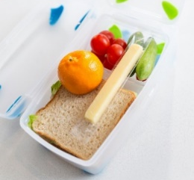
We do realise the difficulty in preparing a healthy, balanced lunchbox for children to sustain their busy minds and bodies during a school day. To support this, Chapman Primary School has a no food sharing policy, and we ask that you speak with your children to remind them not to share their food with anyone at school, even with their best friend, because it may make them very sick.
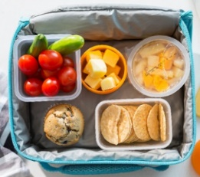
Chapman Primary School supports the Healthy Living Traffic Light System in schools, categorising food and drinks according to their nutritional value and levels of energy, saturated fat, fibre, sugar and salt. This follows guidelines in the ACT Public School Food and Drink Policy which is in line with the Australian Dietary Guidelines and includes the National Healthy School Canteens Guidelines for Healthy Foods and Drinks in School Canteens
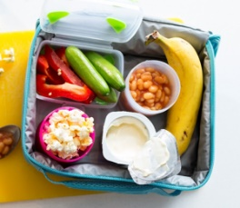
“If kids learn healthy eating habits from an early age, it sets them up for a long and healthy life.” https://www.health.act.gov.au/about-our-health-system/healthy-living/fresh-tastes/about-fresh-tastes
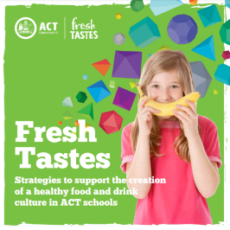
- You can support us by ensuring your child has a lunchbox filled with a good choice of healthy food and drink to fuel them with the right energy to get through a busy day of concentration and play while at school.
- You can support us by ensuring that your child has as many green foods as possible and limiting the number of red foods at school or even saving the red foods such as candy canes and lollies for home.
- You can support us by making sure your child has a reusable water bottle each day that they can refill at our school bubblers.
Yours faithfully
James M. Barnett
Principal

