23 February 2024
Dear kindergarten families,
KINDERGARTEN ‘READING AT HOME’ PROGRAM
Welcome to the ‘Reading at Home’ Program. Our aim is for Chapman Primary School students to develop a love of reading and enjoy this time sharing and talking about stories with their families.
The goal of our ‘Reading at Home’ Program is:
- Enhance student engagement in reading by giving students choice
- Develop confidence in reading
- Develop reading skills through repetition
To achieve these goals, your child will be provided with books and support cards within the ‘Reading at Home’ program to foster their reading development.
Each Friday, your child will bring home:
A book that they have selected from the school library. | When you read this book to your child, you are showing your child that reading is an enjoyable activity. Discussions about the book, before, during and after reading it, are encouraged. This also provides a fantastic opportunity for your child to develop vocabulary - please talk about the interesting words or pictures in the book with your child.
1-3 books that they have selected from the class library. These may be ‘quality texts’ or ‘readers'. | Your child may or may not be able to read these books independently. If they are not able to read them by themselves, please read these books WITH your child by taking turns or asking your child to repeat certain sections.
The reading pouch containing the above books are to be returned and swapped on Fridays. Please support your child to return their books in their pouch on this day. If your child is away or forgets their pouch on Friday, they may bring it in the following school day.
Other supports that will be sent home as required:
Magic Words  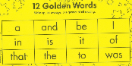 | Magic Words are high frequency words that are listed on coloured cards. As a starting point, your child will receive 1 or 2 lists this term. Many of these words cannot be sounded out. Instant recognition is encouraged. You may wish to celebrate the words your child knows by adding them to a poster on your wall.
Alphabet cards  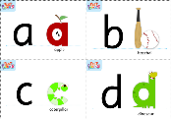 | In kindy, we learn phonics through reading picture books, having fun with rhymes, playing with words and writing meaningful texts. We learn the sounds of the English language and the letters of the alphabet and the relationship between them. You may wish to use these cards for letter identification or to create a word wall at home.
Reading Eggs  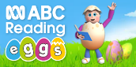 | Your child will be given a Reading Eggs login and password. We strongly recommend that they regularly access this online learn to read program at home.

Reading tips for children:
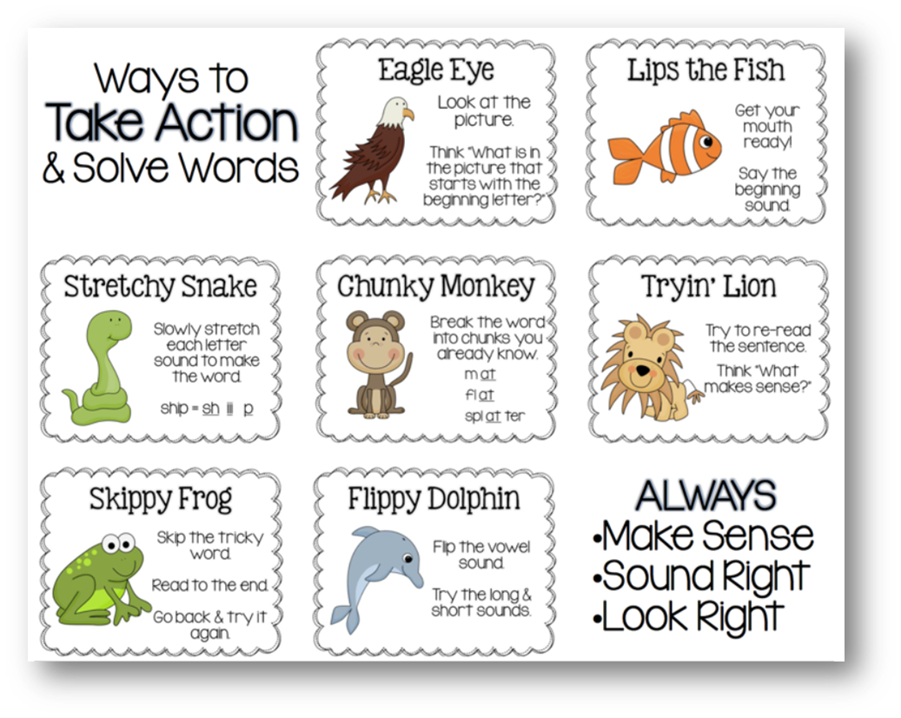
Reading tips for parents:
- Read and talk about books and stories with your child
- Ask about their favourite character in a book or what they think might happen next in the story
- Shared reading activities do not have to be in English to have an impact. If you speak a different language at home, you can speak and tell stories in your first language – this is very beneficial to your child’s education and life experience
- Praise your child for their effort and persistence when they are reading
Ask your child’s teacher for advice or specific strategies to support your child’s enjoyment and skill development in reading

Yours faithfully,
Kindergarten Teaching Team

